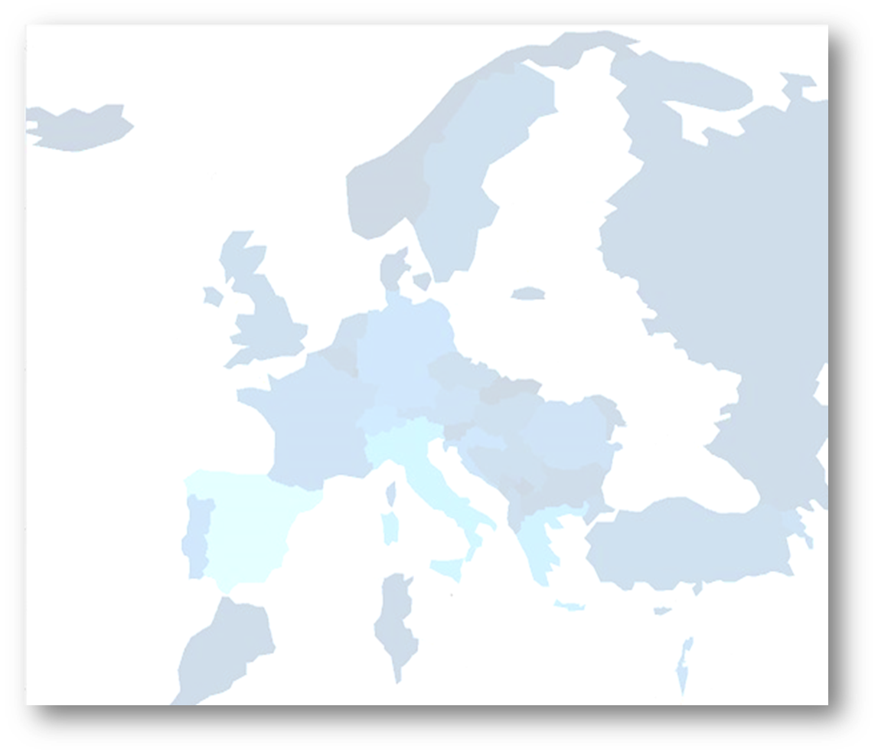
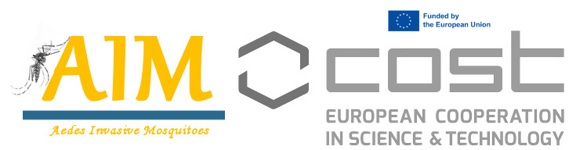
.
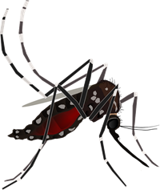
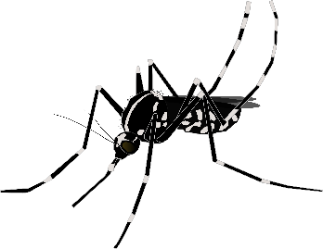
Training School: Finding, using and interpreting maps and models of invasive mosquitoes
Oct 5 to Nov 25 2022
William Wint, Kamil Erguler, Cedric Marsboom, Sophie Vanwambeke, Filiz Gunay, Miguel Miranda, Francis Schaffner
Training School Description and Rationale
In the context of the dissemination activities that are part of AIMCOST Workgroup 3 a virtual workshop on Finding, using and interpreting maps and models of invasive mosquitoes - Step 1 was organised on October 5th 2022.
The Workshop rationale was circulated as follows:
Training Course Objectives
The training course has a number of major objectives:
- To teach participants how to interpret available maps, models and sampling results relating to invasive mosquitoes;
- To use this knowledge to evaluate information available for their region, identify gaps, and propose solutions to fill the gaps;
- To prepare a presentation on their assessments of the situation in their region.
This course is NOT, therefore, aimed at experienced mappers and modellers, but those who need to use and interpret maps and models rather than produce them, such as Public Health professionals, field staff and students.
The course will be divided into three sessions - an introductory virtual session, a face to face day to provide some theoretical overviews and begin the process of preparing the presentations, and a second virtual session to make the presentations. Trainees will be asked to form regional teams to collaborate between the face to face day and the second virtual session to finalise and produce the required presentation..
Training Course Sessions
- 5th October 1100-1315 CET Online. This introductory session will outline the training school objectives and practicalities, provide an overview of AIM-COST recommendations for surveillance and modelling best practice, and provide details of the way to use maps and models to communicate data and results to a range of stakeholders. The trainees will also be asked to arrange themselves into small regional teams ready to participate in the Face to Face day the following week.
- Face to Face day Monday 10th October, the day before the start of the ESOVE conference. Location: Sofia Hotel Balkan, SOFIA, Bulgaria. This face to face training day will consist of two parts - a series of lecture sessions in the morning designed to give trainees an overview of mapping and modelling methods, focusing on what can be done and what cannot be done with these techniques, and illustrating how model and map outputs can be best produced and interpreted. The afternoon sessions will concentrate on helping the participants evaluate the data about invasive mosquitos available at the continental scale and for their region, and starting the process of preparing presentations to be given online in November.
- Presentation of Results. Online, 25th November 1100CET. The trainee teams will present their evaluation and analysis of the information about invasive mosquitos available for their region, identifying any gaps, and specifying what additional information is needed to feed surveillance, control and policy decisions and describing how such information should be obtained. Each presentation will be followed by an open discussion and feedback on potential changes or improvements that could be made. The presentations will be evaluated, and the team giving the presentation with the highest score will be asked to present their findings at the AIM-COST Annual Meeting in Rome at the beginning of February 2023.
SESSION 1: SECOND VIRTUAL SESSION OCTOBER 5TH 2022
The session content is shown below:
Overview of training course content aims and objectives, (William Wint, 20 minutes)
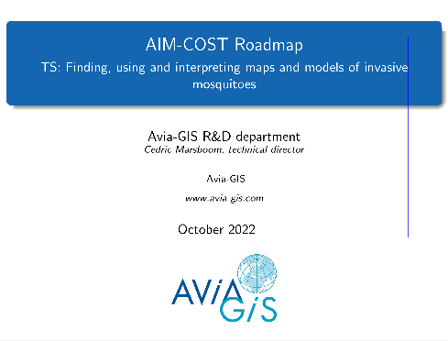
Overview of AIM-COST roadmap (Cedric Marsboom, 20 mins)
One of the deliverables of AIM-COST Workgroup 1 is to produce a ‘Roadmap’ setting out best practice for surveillance, mapping and both spatial and mathematical modelling invasive mosquitoes. In addition, the Roadmap sets out recommended principles of disseminating outputs of these technical activities beyond the spatial analyst and modeller communities.

Best practice for presenting spatial information (Sophie Vanwambeke, 90 mins)
Maps can be an outstanding communication tool and as such it’s not surprising that they have gained so much in popularity now that making them is just a click away on an online mapper. Still, like other tools that collate and present summaries of data and information, preparing, communicating and reading them is not trivial. We will examine in what circumstances maps can be useful, and what are frequent pitfalls of map making and reading. Best practices for communicating spatial data and information will be demonstrated and discussed.
The presentations are available at https://drive.google.com/drive/folders/1IqkFsQN6RvZt1VAkSM2BBu1lvnMsVGwI?usp=sharing

Appendix 1: Advance materials
AIMCOST MODELLING AND MAPPING TRAINING COURSE.

Training objectives
The training course focusses on mapping and modelling. It is NOT the intention to provide technical training on how to actually produce maps or models, but rather to provide a basic understanding of what these activities involve, so that the trainees can interpret the available data effectively, and use the information to identify gaps and recommend actions to remedy the gaps identified.
The first virtual session (oct 5th 1100 CET) focuses on a course Overview and Mapping Principles .
The second Face to Face session in Sofia (October 10th) looks in more detail at using and evaluating distribution and model data. To do this there will be presentations providing overviews of sampling programmes and modelling techniques.
Subsequent sessions will be focused on collaborating within allocated small regional teams. The participants will be asked to utilise their prepared slides to start preparing a team assessment of 10-15 mins about what is missing from the information needed to produce a strategic plan for vector monitoring and disease risk assessment, and what are the policy implications of these gaps. These presentations will be given at the second virtual TS session in November.
Participants are therefore asked to obtain information about vector surveillance and known distributions in their region relating to at least one species, and summarise them on up to three slides, to be prepared before the training course. The content of these slides will be used to collaborate in the regional teams and present team rather than individual presentations. The advance material includes a lot of continental scale distribution information produced by VectorNet to provide a European context for the regional datasets and a series of relevant documents on sampling.
We have provided some advance material at this link https://docs.google.com/document/d/1fLZi-t7Wu5ASTDbJhuAFQCGcsPjjAvAe/edit#
As well as looking at the advance material we have identified two tasks for completion before the face to face day.
Task 1: Identify species of interest and collate some local data for your country/region
You will need to collect material about your regions to use in the presentations. As a reminder, the aim of your presentations which will be discussed and prepared in Sofia, and given live at the virtual session in November

Optional Task 2: Reading maps & drawing conclusions – mini quiz
Three questions with supporting maps to introduce trainees how VectorNet maps have been used to support policy and decision making at different levels. Note we have used some non mosquito species to make various points!

Task 1: Identify species of interest and collate some local data for your country/region
Ideas for content and comment for your slides. Please use the following questions as inspiration for content and themes for your slides.
Please identify the key species that potentially will most impact your work/country now or in the future. Critique the current data presented by VectorNet for those species in your region. Specifically comment on the quantity, quality and identify any gaps. Finally present any data that you can find locally that would further improve the VectorNet coverage.
Presentation Template
A simple presentation template in the form of slide titles is provided with this preliminary material. Slides to be prepared individually prior to the workshop:
Slide 1:Overview of species vector/disease system, and priority mitigation strategy objectives (?nuisance, disease control, vector spread control etc)
Slide 2: Overview of area and information sources,
Slide 3: Overview of existing vector data for selected system
Slides to be prepared with your group as directed at the workshop:
Slide 4: What is missing from info/data needed to provide assessment of vector borne risk
Slide 5: What are policy implications of these gaps

Sample questions you could be asking/answering in your presentation:
How is distribution recording in your region for chosen species? How has that changed over time?
Can we use edges of distribution as target for control or spread monitoring?
Is there reliable abundance data? Regular counts taken in the same location over the season. Repeated over multiple years.
Where are new data needed most, will models be enough or is more surveillance needed?
Looking at the vector maps provided in the reading material list. What are the main VBD risk in your area, and does that agree with national/regional understanding.
What about absence data – can/should this be inferred?
Can we use the maps/models to estimate about potential spread?

Optional Task 2: Reading maps & drawing conclusions – mini quiz
- Looking at the map below. Four (fictional) proposed regions for priority sampling have been identified.
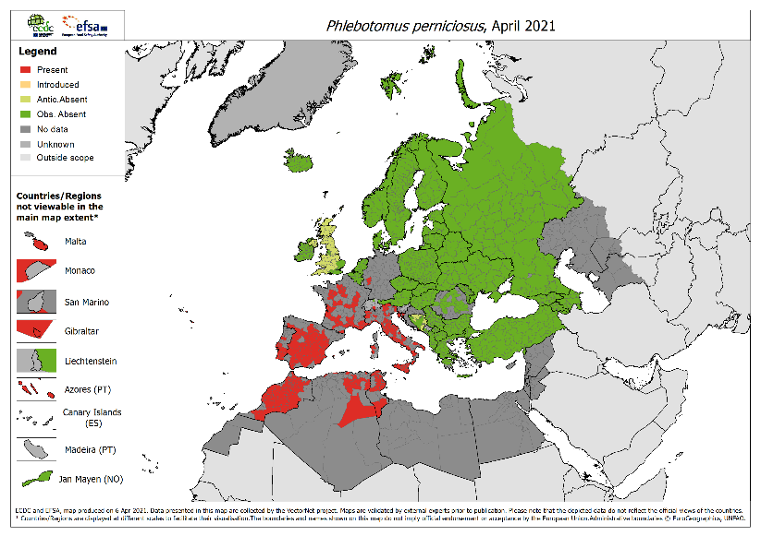

A
B
C A

D A

Using the information on the map order the proposed sites in priority and then in the space provided explain why you selected the most prioritised site and why you selected the least prioritised site.
Site 1 (most important):
Site 2:
Site 3:
Site 4 (least important):

Please outline your rationale here:

- The four maps below overlay presence data points for different tick species available from GBIF over the top of the known distribution according to the VECTORNET database shown in polygons.
VN Dermacentor reticulatus Comparison with GBIF records (points)  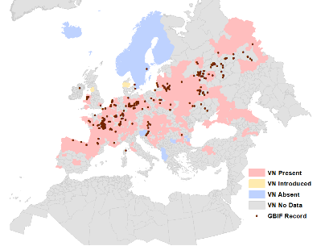  A | VN Ixodes ricinus Comparison with GBI (in Yellow)  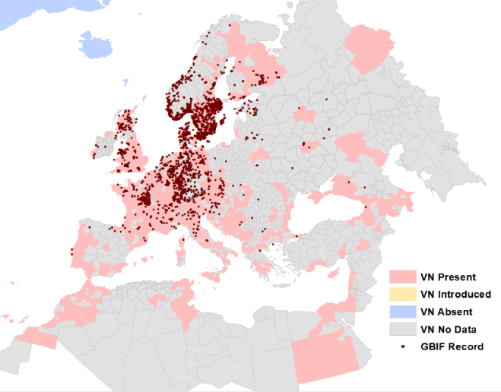  B
VN Rhipicephalus sanguineus Comparison with GBIF records (in Brown)  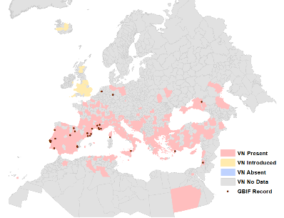  C A | VN Ixodes persulcatus Comparison with GBIF records (in Brown)  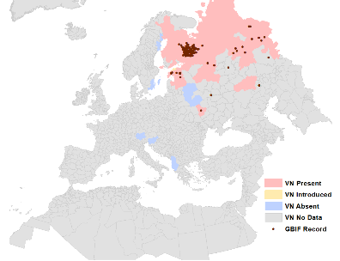  D A

Distribution modelling uses available data to predict where species may be found in areas with no data. The modelling works best if there is a broad spread of data points across the study area. Bearing this in mind...
- Which GBIF dataset if used as a training dataset for modelling is likely to produce the best results, please explain why?

SESSION 2 FACE TO FACE SOFIA, OCTOBER 10TH 2022

TS Content
The session content is shown below:
PROGRAMME
0930 Registration
10:00 - 10:15 Introduction and objectives (Filiz Gunay)
10.15-10.45 AIMSURV – Best practice sampling (Miguel Miranda)
10.45 – 11.15 Mathematical modelling basics (Kamil Erguler)
11:15 - 11:45 Coffee Break
11.45 – 12.45 What is required for (Spatial) modelling (William Wint)
12:45-14:00 Lunch (sandwiches provided)
14:00 - 16:00 Preparation of Presentations, part 1
16:00 - 16:30 Tea Break
16:30-17:30 - Continued preparation of presentations

The trainees were assinged to Teams accoring to their country as follows:
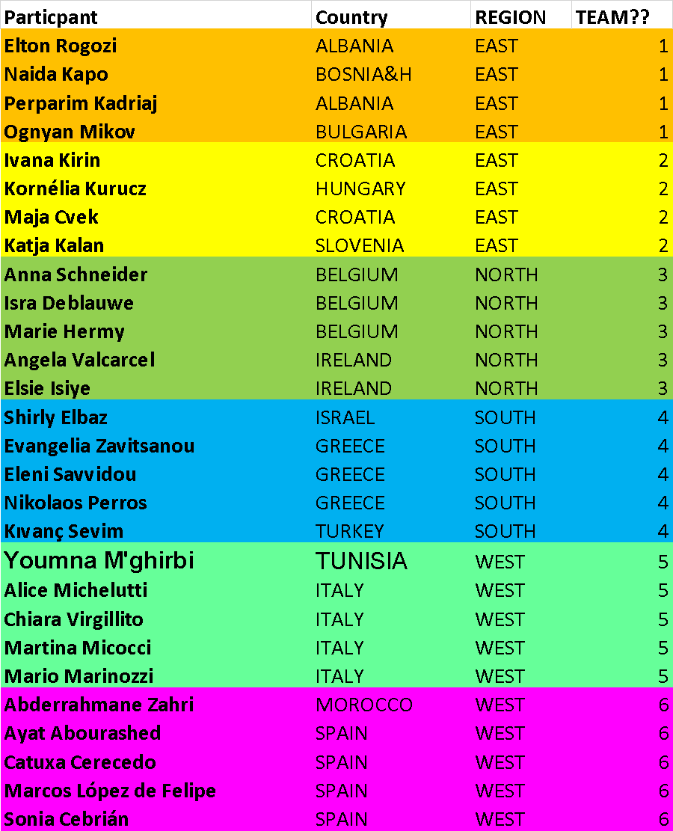

Presentations
1.Best practice sampling (Miguel Miranda)
This session will provide a summary overview of the AIMSURV Initiative, illustrating best practice standardised invasive mosquito sampling as conducted through AIM COST from 2020-2022

2. Mathematical modelling basics (Kamil Erguler)
This session will introduce concepts of inverse modelling, which involves the development and interpretation of process-based mechanistic models. Using simulated data and the AIMSurv dataset, we will discuss model calibration, evaluation, interpretation, and visualisation

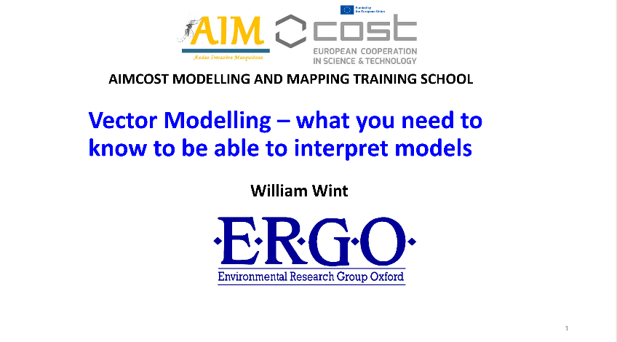
3. What is required for (Spatial) modelling (William Wint)
The session illustrated some of the outputs of spatial models of invasive mosquitoes, and other vectors providing an overview of the methods and summarising the inputs required to feed the models.

4.

These presentations can be downloaded from https://drive.google.com/drive/folders/1NmmcR4HCMlL3q0kiuntJUNr7jdVKkk2m?usp=share_link

SESSION 3: SECOND VIRTUAL SESSION NOVEMBER 25TH 2022
The presentations are summarised as follows:
Presentation Team 1: Here be dragons: mapping and modelling the Balkans. Naida Kapo, Peparim Kadriaj, Ognyan Mikov, Elton Rogozi
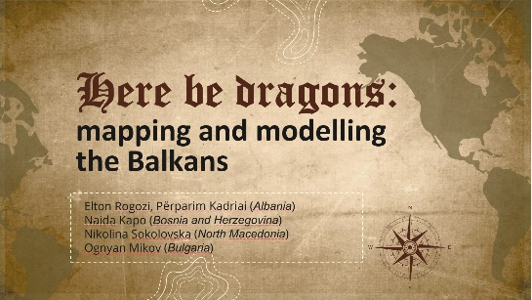
On the European continent, the Balkans have the longest history of interaction with invasive mosquito species. Albania was the first country invaded by the Asian tiger mosquito Aedes albopictus outside its native range and has more than 40 years of experience with the species as of today. Bosnia and Herzegovina, Bulgaria and North Macedonia faced the invasion during the last six to twelve years. Furthermore, all the countries have a long history of surveillance of malaria mosquitoes and nuisance mosquito species and follow the EU mandatory disease reporting system.
Distribution and abundance data on Ae. albopictus exist for different periods and geographic scales in the corresponding countries, with Albania having the largest coverage both time- and area-wise. Generally, these data are not open-access and are only published in reports and scientific articles. Another common feature is the lack of true absence data, which hampers the ability to generate high-quality species distribution models and introduces a higher level of uncertainty in disease risk mapping. Nevertheless, pseudo-absence data can be inferred from the existing records. Other possible sources of obtaining open-access distribution data for Ae. albopictus include the Mosquito Alert database, GBIF and iNaturalist databases.
It is possible to use the existing maps to give an estimation of the vector spread in the surveyed regions, but the necessity to maintain the continuity of monitoring to fill any data gaps in the unexplored areas should be emphasized.

Presentation Team 2; Aedes koreicus in the region of Slovenia, Hungary and Croatia, and risk assessment for Dirofilaria repens infections. Katja Adam, Kornélia Kurucz, Maja Cvek, Ivana Kirin, Kornelia Kurucz.
Among the invasive mosquito species that occur in Europe, Aedes albopictus and Aedes japonicus are common in large areas of Slovenia, Hungary, and Croatia, thus modelling their distribution does not provide additional information in the region. Therefore, our team choose Aedes koreicus as the species of interest for distribution modelling and related risk assessment because it has established populations both in Slovenia and Hungary close to the Croatian border, however, it was not detected in Croatia until now. From a public health point of view, Dirofilaria repens infections, along with the emergence of an alien invasive vector species should pose a significant risk. The filarial nematode is endemic in the region, circulates among dogs, and can infect humans as well with frequent case numbers in Croatia. Also, in Slovenia, five human cases were observed since 2010, and three human D. repens infections were observed recently in Hungary, close to a dog shelter Ae. koreicus is dominant.
To get an overview of the vector-pathogen/disease surveillance system and mitigation strategy objectives, we collected some local data for our countries by using publicly available distribution maps (ECDC, INaturalist, GBIF, Mosquito Alert), scientific papers available on online publication databases (e.g. Web of Science, PubMed, ResearchGate, GoogleScholar), and based on research work of our own institutes and other groups in the targeted countries, along with field monitoring data collected via AIMSurv protocol (by AIM-COST).
After evaluating the information on Ae. koreicus and D. repens that are available in the region, we defined gaps in surveillance needed to provide an assessment of the real-time risk of vector-borne diseases. Since both the pathogen and its vector species are present in the region, and both dog and human cases are observed with increasing frequency, the risk for D. repens infection is notable. However, (1) there are aggregated and small-scale data only that are insufficient for region-wide modelling, (2) there are no pathogen prevalence data from mosquitoes and the risk of exposure is not measured, thus (3) the role of Ae. koreicus in the local circulation of D. repens is not proven. Obviously, there is no targeted control of Ae. koreicus nor Dirofilaria nematodes in the region.
Since there are no policy implications in the region to fulfill these gaps, we made some recommendations for better input data necessary for a region-wide and real-time risk assessment for Ae. koreicus-mediated Dirofilaria transmission, and defined some suggestions to mitigate the risk of vector-borne disease transmission in general.
Presentation Team 3: Monitoring vectors and vector-borne diseases: What is happening in Ireland and Belgium?’. Isra Deblauwe, Elsis Isiye, Marie Hermy, Anna Schneider, Angela Valcarel
Elsie Isiye, Angela Valcarcel Olmeda, Isra Deblauwe, Anna Schneider, Marie Hermy
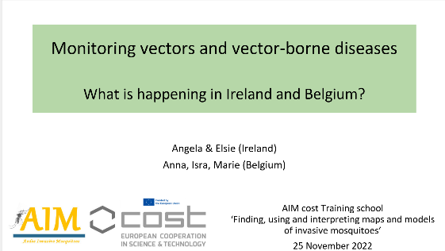
The risk of vector-borne disease outbreak in Belgium and Ireland depends first of all on the presence of the vector and secondly on the presence of the pathogens. Here we will present the situation of both countries with regards to the Asian tiger mosquito (Aedes albopictus). Up until the summer of 2022, there was no report of locally overwintering tiger mosquitoes in either country. The first step in identifying the Points of Entry (PoEs) with a high risk of introduction of Aedes albopictus is by making a risk assessment. The second step is implementing active surveillance at PoEs. For Ireland, up until now, a risk assessment is lacking. Nevertheless, active monitoring has been happening at some PoEs since 2015 and two more PoEs were added in 2017. So far, no introductions of Aedes albopictus have been reported. For Belgium, a first risk assessment was done in 2007 when active mosquito surveillance was implemented. Between 2007 and 2020, 52 PoEs were identified, mainly importers of used tyres, or lucky bamboo companies as well as highway parkings, ports and airports. These 52 PoE’s were sampled at least once over the past 15 years and introductions of tiger mosquitoes were observed from 2013 onwards in several PoE’s. Both countries were in a scenario 1 where no tiger mosquitoes were established. In 2022, a passive surveillance component was added to the already existing active surveillance of PoEs in Belgium. All citizens were invited to join the search for tiger mosquitoes and make a notification with a picture through a participatory platform. This revealed that Belgium is possibly no longer in a scenario 1 situation, but in a scenario 2 situation where there are locally established tiger mosquito populations. Whether the tiger mosquito is overwintering in Belgium or not, has to be confirmed at the beginning of the mosquito season in 2023. The use of European maps and models taking into account factors that contribute to the spread of Aedes albopictus are helpful as they are indicative and they can support policy makers in their decisions to implement surveillance. However, they should be supplemented with actual data and updated over time to be as accurate as possible. To obtain an ideal monitoring strategy for vectors and vector-borne diseases, Ireland should do a risk assessment of PoEs, and implement structural surveillance at these PoEs, taking into account that it is an island, and if possible add a passive monitoring layer. Ideally for Belgium, country-wide structural active monitoring should be added to the existing monitoring in order to collect real presence and absent data.
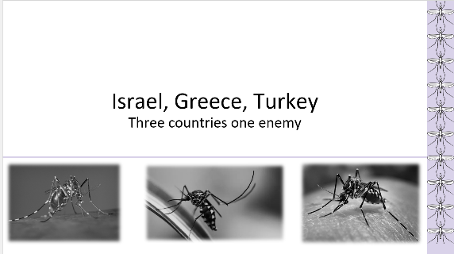
Presentation Team 4: Israel, Greece, Turkey: three countries one enemy. Shirley Elbaz, Nikolaos Perros, Eleni Savvidou, Kivanc Sevim, Evangelina Zavitsanou,
Among the invasive mosquito species (IMS) the Asian tiger mosquito, Aedes (Stegomyia) albopictus (Skuse, 1894) (Diptera: Culicidae), is the most famous in Europe since it has been established in many countries. Several IMS are well- known vectors of diseases, such as Chikungunya, Dengue and Zika virus. Our presentation was about the presence of Aedes albopictus in our three countries: Israel, Greece and Turkey. The first detection of Aedes albopictus was at Israel, 2002, then at Greece and finally at Turkey. In our exercise we used maps from European Centre for Disease Prevention and Control and maps that made from our team, to depict the spreading of Aedes albopictus thru the last years. Finding the gaps that all these three countries have, we discussed about the solutions and all the team concluded that a country needs not only enough traps but also scientific staff for research, and a very supportive state.

Presentation Team 5: Mosquito Alert: advantages and disadvantages of its application in Aedes Invasive Mosquito surveillance. Mario Marinozzi, Youmna M’ghirbi, Alice Michelutti, Martina Micocci, Chiara Virgillito
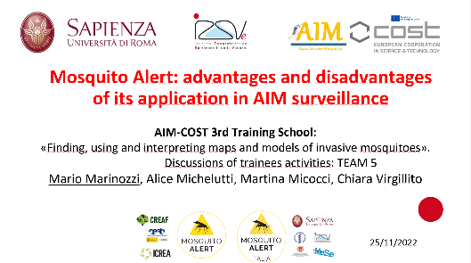
MOSQUITO ALERT is a free app which allows citizens to send to experts photographic reports of mosquitoes and mosquito breeding-sites and report bites. The set of reports are validated by expert and integrated into interactive open-access maps that can be consulted via web at any time by everyone who is interested. Mosquito Alert Italia is a network of research groups - coordinated by Sapienza University of Rome (DSPMI) and including: Istituto Zooprofilattico Sperimentale delle Venezie (IZSVe), Museo di Scienze di Trento (MUSE), Istituto Superiore della Sanità (ISS), Alma Mater Studiorum Università di Bologna (UniBo) - that manage a “citizen science” project largely based on Mosquito Alert app since October 2022, when it was released in 19 European languages including Italian. In 2022 (January 1st to November 17th), this effort led to 10,379 reports, of which 5,186 photographic reports of mosquitoes, 4,969 reports of bites and 224 reports of breeding sites sent from Italy. We used these original data to produce:
1) quarterly maps of validated photographic reports of mosquitoes. These show that the seasonality of the trend is consistent with mosquito seasonality in Italy, with higher number of reports in the 2nd and 3rd quarters and still several reports in Oct-Nov. Spatially, there a higher number of records comes from areas with a greater concentration of people and where Mosquito Alert Italia members are based.
2) spatial maps of Culex spp. (N=626) and Aedes albopictus (N=1,466) across Italy. The number of species reported was low for Ae. koreicus (7) and japoincus (3), higher for Culex spp. (626), and more than double for Ae. albopictus (1,466). The geographical distribution of records is widespread and consistent with the overall map above.
3) a video of bite reports during the study period. These show two peaks, in June and September, reflecting the timing of the two Mosquito Alert Italia press releases. Spatially, biting reports are distributed in all regions, but again with a higher concentration in more densely inhabited areas.
These maps show the potential of the involvement of citizen in providing large scale data also from areas where no entomological monitoring is carried out and few data on mosquito presence/distribution are available. The main limitation of these maps is the lack of “absence data”. In fact, at present the maps show only presence data, which are widely affected by user distributions and by promotional events. Mosquito Alert experts in Spain are working on algorithms which allow to take sampling effort by citizens and propensity scores into consideration.

Presentation Team 6: Modeling Ae. albopictus Distribution: The Barcelona Case Study as Inspiration for Madrid & Rabat. Ayat Abourashed, Catuxa Cerecedo Iglesias, Marcos López de Felipe, Sonia Cebrián Camisón, Zahri Abderrahmane
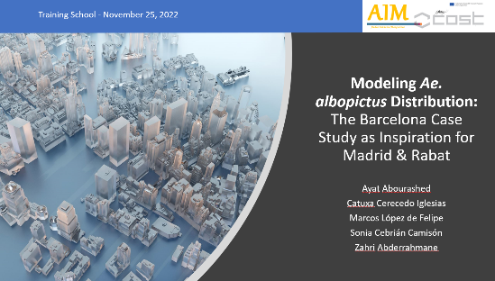
In recent years, Spain and Morocco have developed a common invasive vector: Aedes albopictus. Besides it's clear biting nuisance, Ae. Albopictus poses a public health risk by transmitting several arboviruses. Getting a better understanding of this vector's potential whereabouts and predicting its spread is crucial to creating a mitigation strategy. We decided to investigate what surveillance data is available specifically in Madrid, Spain and Rabat, Morocco in order to create vector distribution maps. The first Ae. Albopictus cases were detected in Madrid and Rabat in 2018 and 2015, respectively. Since then, various data sources have been used to predict Ae. Albopictus’s potential whereabouts in these areas. We decided to investigate Mosquito Alert’s MosquitoAlertBCN project, which combines citizen science data with traditional surveillance data, and assess if the MosquitoAlertBCN model can be replicated in Madrid and Rabat. For Madrid, while the surveillance process is not completely streamlined, there seems to be accessible data and clear protocols for traps, so creating a model similar to MosquitoAlertBCN should be possible. In Rabat, while people are attempting to create distribution models, most data is not accessible or is not robust enough to build a MosquitoAlertBCN-like model. With that in mind, making Ae. albopictus distribution models in Madrid and Rabat will hopefully be possible by educating citizens and involving them in the surveillance effort. It is clear that both active and passive sampling efforts are needed to establish robust surveillance programs to develop strong models.

All the presentations, and the session programme can be downloaded from the following link: https://drive.google.com/drive/folders/1aZyCsOAFlmWKXjb46oEhUF0dwp840S5C?usp=share_link

