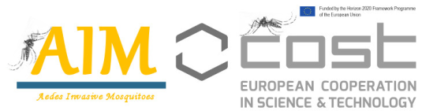
First AIM-COST Annual Coference and Working Group meetings
ATHENS, 13-14 February 2019 www.aedescost.eu

Application to Attend Conference

Applicant name: ___________________________________________________________________

Applicant affiliation: ___________________________________________________________________

Applicant e-mail: ___________________________________________________________________

Gender: F □ M □ Years from PhD: ≤ 8 years □ >8 years □

Motivation letter (max 400 words)
Please explain why you wish to attend the AIM-COST conference, and how it will benefit your research.

CV (max 3 pages) attached

